

**INTERNATIONAL SCHOOL**

**PROJECT 1**

**CMU-CS 246 FIS**

**USER INTERFACE DESIGN DOCUMENT**

Version: 2.0

**CALCULATE WITH ME SYSTEM**

**Mentor: Nguyen Dang Quang Huy**

***Team Member*:**

Le Phan Nhat Linh

Hoang Thi Thanh Nhan

Le Truong Huy

Do Tuan Kiet

**Approved by Huy Nguyen Dang Quang**

**User Interface Review Panel Representative:**

Name Signature Date

**Project 1 - Mentor:**

Name Signature Date

Feb 26, 2024

**PROJECT INFORMATION**

|  |  |
| --- | --- |
| **Project Acronym** |  |
| **Project Title** | Calculate with me system | | | |
| **Start Date** | Feb 19, 2024 | **End Date** | Feb 26, 2024 | |
| **Lead Institution** | International School, Duy Tan University | | | |
| **Team Member** | **Name** | **Email** | | **Phone** |
| 28209051078 | Le Phan Nhat Linh | [Lepnhatlinh1@dtu.edu.vn](mailto:Lepnhatlinh1@dtu.edu.vn) | | 0931950814 |
| 28209005006 | Hoang Thi Thanh Nhan | [Hoangtthanhnhan3@dtu.edu.vn](mailto:Hoangtthanhnhan3@dtu.edu.vn) | | 0849013741 |
| 28211353019 | Do Tuan Kiet | [Dotuankiet1@edu.edu.vn](mailto:Dotuankiet1@edu.edu.vn) | | 0901978272 |
| 28219004110 | Le Truong Huy | [letruonghuy@dtu.edu.vn](mailto:letruonghuy@dtu.edu.vn) | | 0775999827 |

**PROJECT PLAN DOCUMENT**

|  |  |  |  |
| --- | --- | --- | --- |
| **Document Title** | User Interface Document | | |
| **Author(s)** | Team 6 | | |
| **Date** | Feb 25, 2024 | **File name:** | CMU-CS 246 FIS – TEAM 6 |
| **URL** | https://drive.google.com/drive/folders/1yVWWbBrti5yHXNfN4gMHu0odNa4-KMox | | |
| **Access** |  | | |

**SIGNATURE**

**Document Approvals:** The following signatures are required for approval of this document.

|  |  |  |  |
| --- | --- | --- | --- |
| **Mentor** | Huy, Nguyen Dang Quang | **Signature:** |  |
| **Date:** |  |

**TABLE OF CONTENTS**

**I.** **INTRODUCTION 6**

**1. PURPOSE 6**

**2. SCOPE 6**

**II.** **LIST OF USER INTERFACE 7**

**1. BUSINESS FUNCTION DIAGRAM: 7**

**2.** **CALCULATE WITH ME 8**

**III.** **DESCRIBE USER INTERFACE 9**

**1.** **INTERFACE 10**

**2.** **DESCRIBE UI 10**

## 

**TABLES**

**Table 1: List of Interface**

**Table 2: Describe User Interface Login page**

**Table 3: Describe User Interface Manage Accounts page**

**Table 4: Describe User Interface Add Account page**

**Table 5: Describe User Update account page**

**Table 6: Describe User Manage employee page**

# I. INTRODUCTION

## 1. PURPOSE

# This document describes a computer system that includes all the basic calculations and details of the implementation. The purpose of this document is as follows:

# · Support project managers to have an overview of the system and prepare project estimates

# · To describe use cases in detail. Based on this documentation, architectural analysts and designers will be able to implement the system with ease.

# · Support testers (QCs) in writing acceptance tests and test plans.

## 2. SCOPE

# This document helps to understand better the interface of the System, detailed specification components, and function of the System.

# With this document, the development team can understand the structure and composition to create a consistent and complete system.

# Overview of the stages and modules of the software and create a complete interface.

# This document is intended for the following audiences:

# Technical reviewers including:

# Project Managers

# System Architects

# Designers

# Implementers

# Developers

# Testers

# 

# II. LIST OF USER INTERFACE

## BUSINESS FUNCTION DIAGRAM:

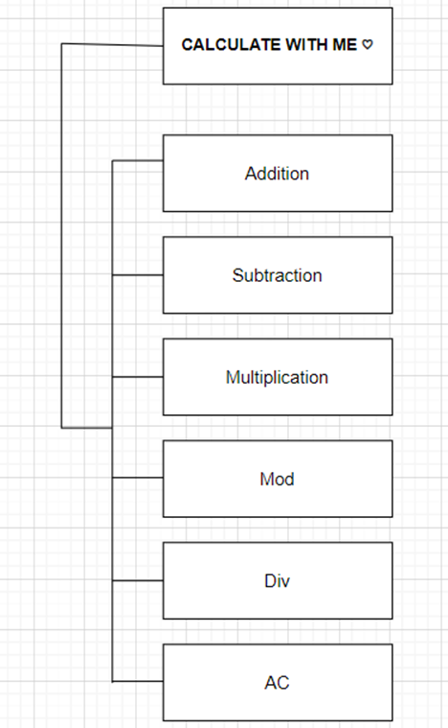

*Figure 1: Business Function diagram*

## CALCULATE WITH ME

|  |  |  |
| --- | --- | --- |
| **User Interface ID** | **UI Name** | **Description** |
| UI-01 | Addiction | This use case allows the user to perform an arithmetic "+" operation. |
| UI-02 | Subtraction | This use case allows the user to perform an arithmetic "-" operation. |
| UI-03 | Multiplication | This use case allows the user to perform an arithmetic "*" operation. |
| UI-04 | Div | This use case allows the user to perform an arithmetic "/" operation. |
| UI-05 | Mod | This use case allows the user to perform an arithmetic "%" operation. |
| UI-06 | AC | This use case allows the user to perform an "AC" or reset operation. |

*Table 1: List of Interface*

# III. DESCRIBE USER INTERFACE

### Interface

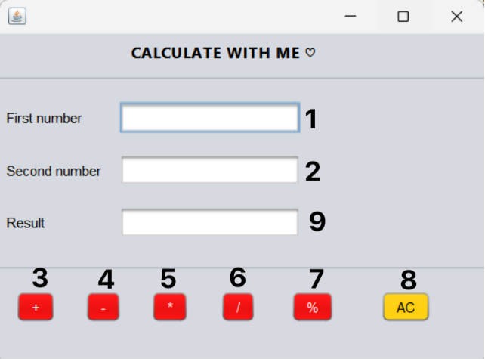

1. Describe UI

|  |  |  |  |
| --- | --- | --- | --- |
| **ID** | **Condition** | **Control Type** | **Target** |
| 1 | Press | Input text | Enter the first number |
| 2 | Press | Input text | Enter the second number |
| 3 | Press | Button | Select the “+” button |
| 4 | Press | Button | Select the “-” button |
| 5 | Press | Button | Select the “*” button |
| 6 | Press | Button | Select the “/” button |
| 7 | Press | Button | Select the “%” button |
| 8 | Press | Button | Select the “AC” button |
| 9 | View | Text Field | Display the results |